Administrative module of caBench-to Bedside V 3.1 v3.1
Design Document

Document Change History
Version Number | Date | Contributor | Description
V1.0 draft | June 21, 2008 | Washington University/Persistent Systems | Draft document
V1.0 | July 22, 2008 | Washington University/Persistent Systems | Reviewed and updated for caB2B v2.0 release
V2.0 | October 1, 2009 | Washington University/Persistent Systems Ltd/National cancer Institute | Draft



This is a U.S. Government work. October 26, 2009

Development Teams
Development | Design document | Program Management
Chandrakant Talele¹ | Chandrakant Talele¹ | Dr. Rakesh Nagarajan²
Chetan Patil¹ | Chetan Patil¹ | Srikanth Adiga^{1, 2}
Chetan Pundhir¹ | Chetan Pundhir¹ | Chandrakant Talele¹
Deepak Shingan¹ | Deepak Shingan¹ | Mukesh Sharma²
Gaurav Mehta¹ | Gaurav Mehta¹ | Stephen A. Goldstein³
Pallavi Mistry¹ | Pallavi Mistry¹
Rajesh Vyas¹ | Rajesh Vyas¹
¹Persistent Systems Limited | ²Washington University
³Sapient Corporation | ⁴Capability Plus Solutions

Contacts and Support
Training contact | cab2bsupport@bmi.wustl.edu
Customer support contact | cab2bsupport@bmi.wustl.edu
Copyright and License Information
Copyright Notice. Copyright 2005 “School of Medicine, Washington University in St. Louis” (“caBIG® Participant”). cancer Bench-to-Bedside was created with NCI funding and is part of the caBIG® initiative. The software subject to this notice and license includes both human readable source code form and machine readable, binary, object code form (the “caBIG® Software”).
This caBIG® Software License (the “License”) is between caBIG® Participant and You. “You (or “Your”) shall mean a person or an entity, and all other entities that control, are controlled by, or are under common control with the entity. “Control” for purposes of this definition means (i) the direct or indirect power to cause the direction or management of such entity, whether by contract or otherwise, or (ii) ownership of fifty percent (50%) or more of the outstanding shares, or (iii) beneficial ownership of such entity.
License. Provided that You agree to the conditions described below, caBIG® Participant grants You a non-exclusive, worldwide, perpetual, fully-paid-up, no-charge, irrevocable, transferable and royalty-free right and license in its rights in the caBIG® Software, including any copyright or patent rights therein that may be infringed by the making, using, selling, offering for sale, or importing of caBIG® Software, to (i) use, install, access, operate, execute, reproduce, copy, modify, translate, market, publicly display, publicly perform, and prepare derivative works of the caBIG® Software; (ii) make, have made, use, practice, sell, and offer for sale, and/or otherwise dispose of caBIG® Software (or portions thereof); (iii) distribute and have distributed to and by third parties the caBIG® Software and any modifications and derivative works thereof; and (iv) sublicense the foregoing rights set out in (i), (ii) and (iii) to third parties, including the right to license such rights to further third parties. For sake of clarity, and not by way of limitation, caBIG® Participant shall have no right of accounting or right of payment from You or Your sublicensees for the rights granted under this License. This License is granted at no charge to You. Your downloading, copying, modifying, displaying, distributing or use of caBIG® Software constitutes acceptance of all of the terms and conditions of this Agreement. If you do not agree to such terms and conditions, you have no right to download, copy, modify, display, distribute or use the caBIG® Software.
- Your redistributions of the source code for the caBIG® Software must retain the above copyright notice, this list of conditions and the disclaimer and limitation of liability of Article 6 below. Your redistributions in object code form must reproduce the above copyright notice, this list of conditions and the disclaimer of Article 6 in the documentation and/or other materials provided with the distribution, if any.
- Your end-user documentation included with the redistribution, if any, must include the following acknowledgment: “This product includes software developed by School of Medicine, Washington University in St. Louis.” If You do not include such end-user documentation, You shall include this acknowledgment in the caBIG® Software itself, wherever such third-party acknowledgments normally appear.
- You may not use the names “School of Medicine, Washington University in St. Louis”, “The National Cancer Institute”, “NCI”, “Cancer Bioinformatics Grid” or “caBIG®” to endorse or promote products derived from this caBIG® Software. This License does not authorize You to use any trademarks, service marks, trade names, logos or product names of either caBIG® Participant, NCI or caBIG®, except as required to comply with the terms of this License.
- For sake of clarity, and not by way of limitation, You may incorporate this caBIG® Software into Your proprietary programs and into any third party proprietary programs. However, if You incorporate the caBIG® Software into third party proprietary programs, You agree that You are solely responsible for obtaining any permission from such third parties required to incorporate the caBIG® Software into such third party proprietary programs and for informing Your sublicensees, including without limitation Your end-users, of their obligation to secure any required permissions from such third parties before incorporating the caBIG® Software into such third party proprietary software programs. In the event that You fail to obtain such permissions, You agree to indemnify caBIG® Participant for any claims against caBIG® Participant by such third parties, except to the extent prohibited by law, resulting from Your failure to obtain such permissions.
- For sake of clarity, and not by way of limitation, You may add Your own copyright statement to Your modifications and to the derivative works, and You may provide additional or different license terms and conditions in Your sublicenses of modifications of the caBIG® Software, or any derivative works of the caBIG® Software as a whole, provided Your use, reproduction, and distribution of the Work otherwise complies with the conditions stated in this License.
- THIS caBIG® SOFTWARE IS PROVIDED "AS IS" AND ANY EXPRESSED OR IMPLIED WARRANTIES (INCLUDING, BUT NOT LIMITED TO, THE IMPLIED WARRANTIES OF MERCHANTABILITY, NON-INFRINGEMENT AND FITNESS FOR A PARTICULAR PURPOSE) ARE DISCLAIMED. IN NO EVENT SHALL THE SCHOOL OF MEDICINE, WASHINGTON UNIVERSITY IN ST. LOUIS OR ITS AFFILIATES BE LIABLE FOR ANY DIRECT, INDIRECT, INCIDENTAL, SPECIAL, EXEMPLARY, OR CONSEQUENTIAL DAMAGES (INCLUDING, BUT NOT LIMITED TO, PROCUREMENT OF SUBSTITUTE GOODS OR SERVICES; LOSS OF USE, DATA, OR PROFITS; OR BUSINESS INTERRUPTION) HOWEVER CAUSED AND ON ANY THEORY OF LIABILITY, WHETHER IN CONTRACT, STRICT LIABILITY, OR TORT (INCLUDING NEGLIGENCE OR OTHERWISE) ARISING IN ANY WAY OUT OF THE USE OF THIS caBIG® SOFTWARE, EVEN IF ADVISED OF THE POSSIBILITY OF SUCH DAMAGE.
Contents
Chapter 1 Introduction 1
Chapter 2 Loading Models 2
Overview 2
APIs Used 2
Implementation 3
Process of loading models 3
Classes involved 3
Sequence Diagram 4
Fetch All Available Models 4
Fetch Model 5
Chapter 3 Configure Service Instances 6
Overview 6
APIs Used 6
Application flow 6
Database schema 7
Chapter 4 Directed Acyclic Graph (DAG) 8
Overview 8
Class Diagram 8
Chapter 5 Curate Path 10
Overview 10
Interface diagram 10
Class Diagram 11
Database schema 11
User interface 12
Sequence Diagram 14
Chapter 6 Category Creation 16
Overview 16
Sequence Diagrams 16
Chapter 7 Inter-Model Join 18
Overview 18
Class Structure 18
Database schema 18
Sequence Diagram 19
Chapter 8 Model Groups 21
Requirement 21
Classes Involved 21
Server Classes: 21
Common Classes: 21
Database Schema 22
Sequence Diagram for Saving Model Group 22

Introduction
This document explains the design of the components and modules present in caBench-To-Bedside Administrator (caB2B-Admin) project. It provides details of different components that are being developed as a part of caB2B-Admin application.

Loading Models

Overview
One of the basic requirements of caB2B is to be able to fetch models from the caDSR and populate metadata repository (MDR) from that. It will be used to build metadata-based queries to fetch data from data services. In order to understand the design of load model in cab2b admin it is necessary to first understand the design and concept of MDR.
MDR stores the metadata for an UML model including its semantic annotations such as all CDEs including permissible values by decomposing the annotated UML model obtained from caDSR.
It also contains all-to-all paths between every two classes. Given the amount of information it stores, it is also possible to get all the paths between two classes across two different UML models based on semantic interoperability.
The design of MDR is the foundation for caB2B backend. It enables the caB2B query engine to provide the following functionalities:
- Metadata search
- Auto generation of user interface for entering predicates
- Automatic path resolution between two query predicates
- Category support
- Inter model queries based on semantic joins

APIs Used
Following APIs are used to fetch the Domain-Model from caDSR.
Classes used are
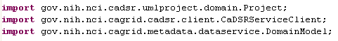

To get projects from caDSR
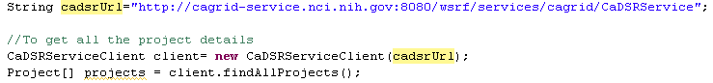

To generate models from projects
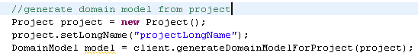

Implementation

Process of loading models
Process of loading models can be divided into two steps
- Fetching all the available models to load
In the first step, all the models available for the loading are fetched. Only the models that are not present in the local database are shown to the user for selection.
- Loading the user selected models
In this step user selects the models to be loaded from UI. These user-selected models are then loaded into the MDR.

Classes involved
The classes involved in this module are:
- SearchDataHeader.jsp is the starting point for the Load Model functionality where user selects the Load Model link from the popup menu list.
- CaDSRLoadModel.java is the struts action called by the Load Model button; this class is a controller used to control the flow of the request.
- CaDSRLoadModelBizLogic.java is used to get all the model names available for loading. This class uses CaDSRServiceClient to fetch all the models for loading. All these models are then filtered to choose only models that not already present in the local database. This class is also responsible for loading user-selected models into the MDR using PathBuilder.
- PathBuilder.java class is responsible for loading the model into MDR
- LoadModel.jsp is the UI page that displays the model names and description for that model. It also allows user to select the multiple models to load.
- LoadModel.java is the struts action that is called by the LoadModel.jsp page.

Sequence Diagram

Fetch All Available Models
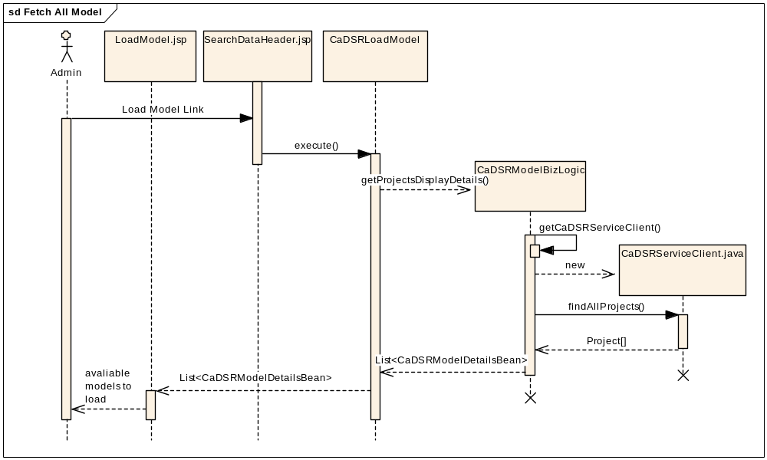
Figure 1 Sequence diagram depicting fetching all available models

Fetch Model
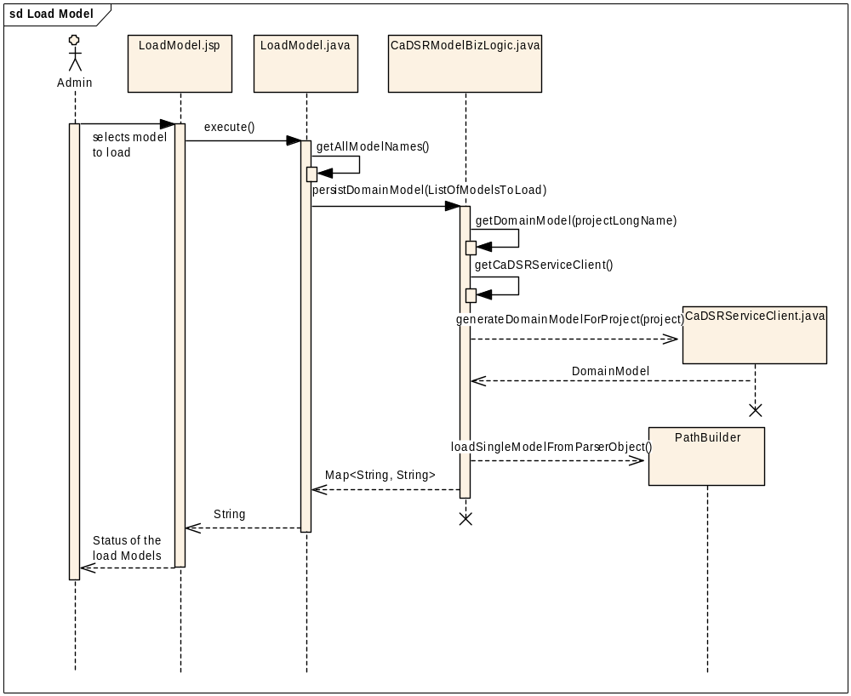
Figure 2 Sequence diagram depicting fetching selected model

Configure Service Instances

Overview
Service instance configuration from admin module involves configuring the URLs of the different services for which the models are already loaded in the application. One model can have multiple service instances configured for it. This involves two stages:
- Fetching the list of all the services available for a certain model
- Saving the selected instances’ URLs into database

APIs Used
Following are the APIs used for service-instance-configuration functionality
Classes used are
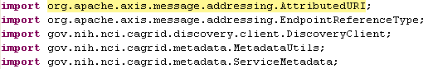

Fetching service instances:
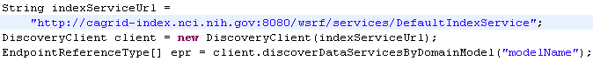

Fetching metadata for each instance:
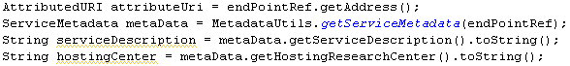

Application flow
Under Search Data menu, administrator selects “Service Instance”. The admin will be shown models currently present in MDR.
User clicks on the model name to see running services which are using that model Name of the selected model is passed to DiscoveryClient‘s method, discoverDataServicesByDomainModel (String modelName). It returns EndPointReferenceType[].
Metadata for each of the EndPointReferenceType is fetched using methods on MetadataUtils class.
Using this metadata, an object of ServiceMetadata class is created for each of the EndPointReferenceType.
The ServiceMetadata objects are used to display hosting center’s information.
User selects the instances that are to be saved. These are saved through saveServiceInstances(Collection<AdminServiceMetadata> serviceMetadataObjects, String userName) in ServiceInstanceBizLogic class.

Database schema
The DDL of the tables will be
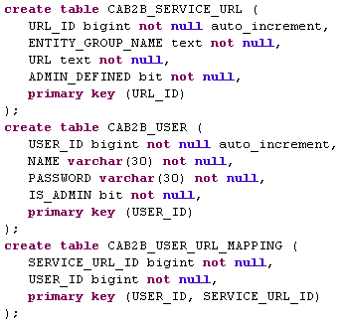

Directed Acyclic Graph (DAG)

Overview
Directed Acyclic Graph (DAG) is a component to be used in a web application that allows user to build and visualize graph. It is developed in Flex and is shared between following functionalities:
- Create category
- Define intermodel joins
- Curate Paths

Class Diagram
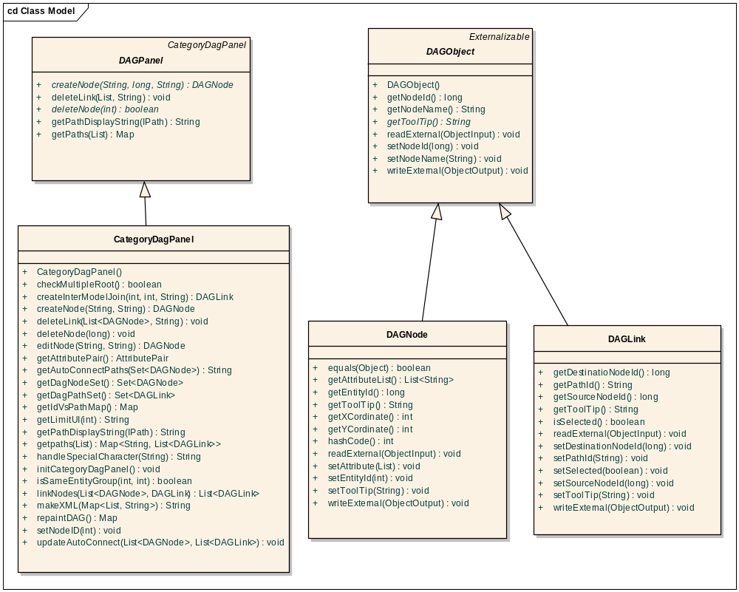
Figure 3 Class diagram of DAG
Description of classes:
  - DAGObject
This class represents the basic structure of Directed Acyclic Graph (DAG).
  - DAGNode
Each entity is represented by a DAGNode in DAGView. Each DAGNode has a unique Id and toolTip that shows all the attributes of an entity added in DAGView.
  - DAGLink
It represents the link between two entities added as DAGNode.
  - DAGPanel
This is an abstract class representing a DAG panel
  - CategoryDagPanel
It represents all the business methods called from Flex UI part .It is registered in remote-config.xml to create the communication between Flex (UI part) to server (java classes). This class is called by DAG.mxml

Curate Path

Overview
Refer to the requirement document to understand the expected functionality of path curation. IAssociation represents a direct linkage between two classes. There are two extensions of IAssociation.
- IIntraModelAssociation represent the link between two classes from the same model.
- IInterModelAssociation represent the link between two classes from different models.
An IPath represents a navigable way between a source and a destination class. It is composted list of IAssociation. It will have at least one
ICuratedPath is defined for set of entities (classes); it is composed of one or many IPath which form a non-cyclic graph between given set of entities.
The implementing classes of these interfaces are hibernate objects. Save-Update-delete operations will be performed using DAO pattern. The interface structure will be as follows

Interface diagram
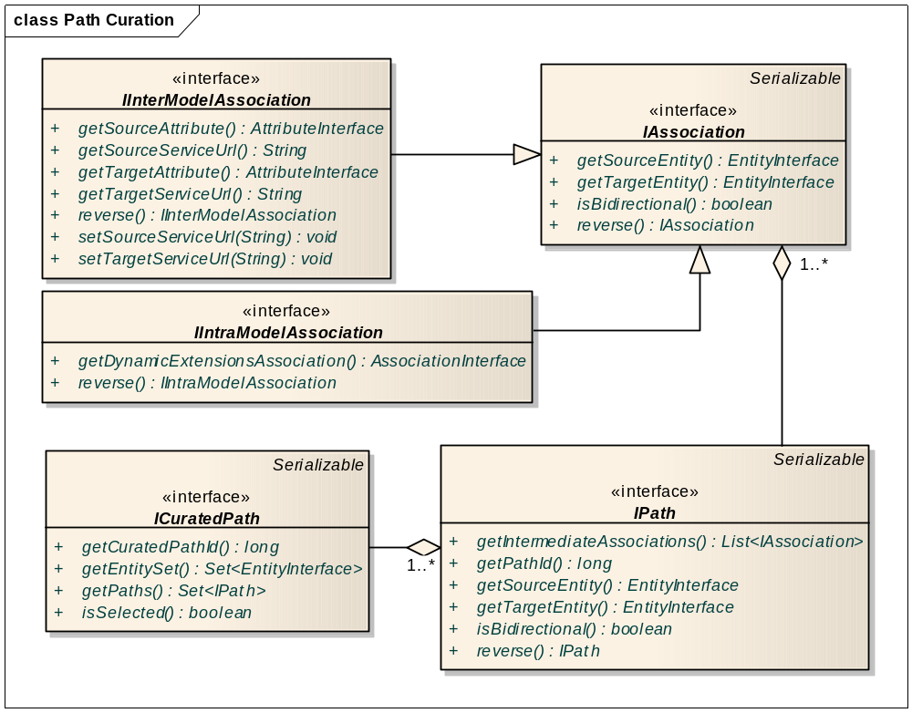
Figure 4 Path Curation Interface

Class Diagram
The classes involved in the path curation will be as follows
- ModelAssociation implements IAssociation
- InterModelAssociation implements IInterModelAssociation extends ModelAssociation
- IntraModelAssociation implements IIntraModelAssociation extends ModelAssociation
- Path implements IPath
- CuratedPath implements ICuratedPath
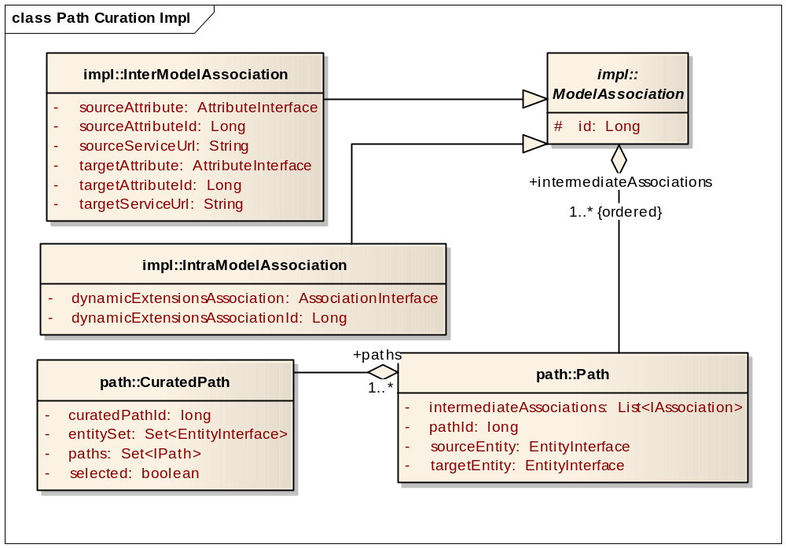
Figure 5 Path Curation Java beans

Database schema
/*
* INTERMEDIATE_PATH contains ASSOCIATION(ASSOCIATION_ID)
* connected by underscore
*/
create table PATH(
PATH_ID bigint not null,
FIRST_ENTITY_ID bigint null,
INTERMEDIATE_PATH varchar(1000) null,
LAST_ENTITY_ID bigint null,
primary key (PATH_ID),
index INDEX1 (FIRST_ENTITY_ID,LAST_ENTITY_ID)
);

/* Possible values for ASSOCIATION_TYPE are 1 and 2
* ASSOCIATION_TYPE = 1 represents INTER_MODEL_ASSOCIATION.
* ASSOCIATION_TYPE = 2 represents INTRA_MODEL_ASSOCIATION.
*/
create table ASSOCIATION(
ASSOCIATION_ID bigint not null,
ASSOCIATION_TYPE INT(8) not null ,
primary key (ASSOCIATION_ID)
);

create table INTER_MODEL_ASSOCIATION(
ASSOCIATION_ID bigint not null references ASSOCIATION(ASSOCIATION_ID),
LEFT_ENTITY_ID bigint not null,
LEFT_ATTRIBUTE_ID bigint not null,
RIGHT_ENTITY_ID bigint not null,
RIGHT_ATTRIBUTE_ID bigint not null,
primary key (ASSOCIATION_ID)
);

create table INTRA_MODEL_ASSOCIATION(
ASSOCIATION_ID bigint not null references ASSOCIATION(ASSOCIATION_ID),
DE_ASSOCIATION_ID bigint not null,
primary key (ASSOCIATION_ID)
);

create table CURATED_PATH (
curated_path_Id BIGINT,
entity_ids VARCHAR(1000),
selected boolean,
primary key (curated_path_Id)
);

/*this is mapping table for many-to-many relationship between tables PATH and CURATED_PATH */
create table CURATED_PATH_TO_PATH (
curated_path_Id BIGINT references CURATED_PATH (curated_path_Id),
path_id BIGINT references PATH (path_id),
primary key (curated_path_Id,path_id));

User interface
The user interface of the path curation will be created using Flex. The communication between Flex and java will happen as shown in the diagram below.
- DAGObject
It is a java bean, which is base class for all the components that can be displayed in
- AmbiguityPanel.mxml
Flex component to show all the paths and allows admin to choose one that will be part of curated path.
- DAGNode.mxml
Flex component to represent a link between two nodes. The java representation of this is DAGNode

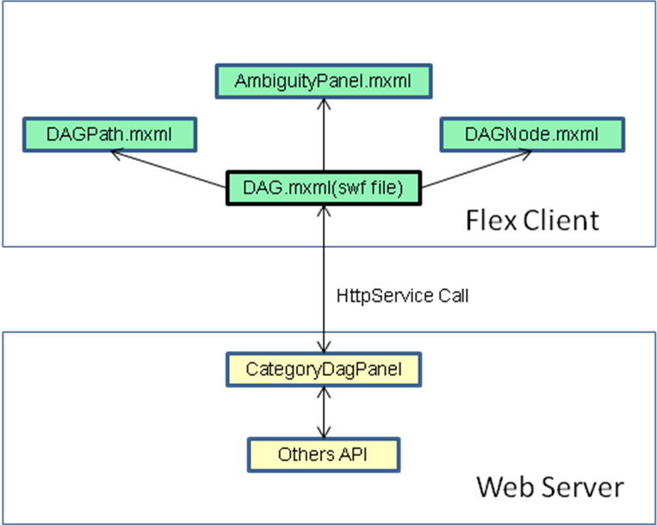
Figure 6 User Interface diagram of Curate Path
- DAGPath.mxml
Flex component to represent a link between two nodes. The java representation of this is DAGLink
- DAG.mxml
Main flex component that displays all other components. This class will be called from java script. This is flex side of the component
- CategoryDAGpanel
All communication from java to flex will be handled by HTTPSevice calls between DAG.mxml and CategoryDAGpanel .This extends DAGPanel and implements all the business logic.
- DAGPanel
It contains all the business logic needed for path curation.

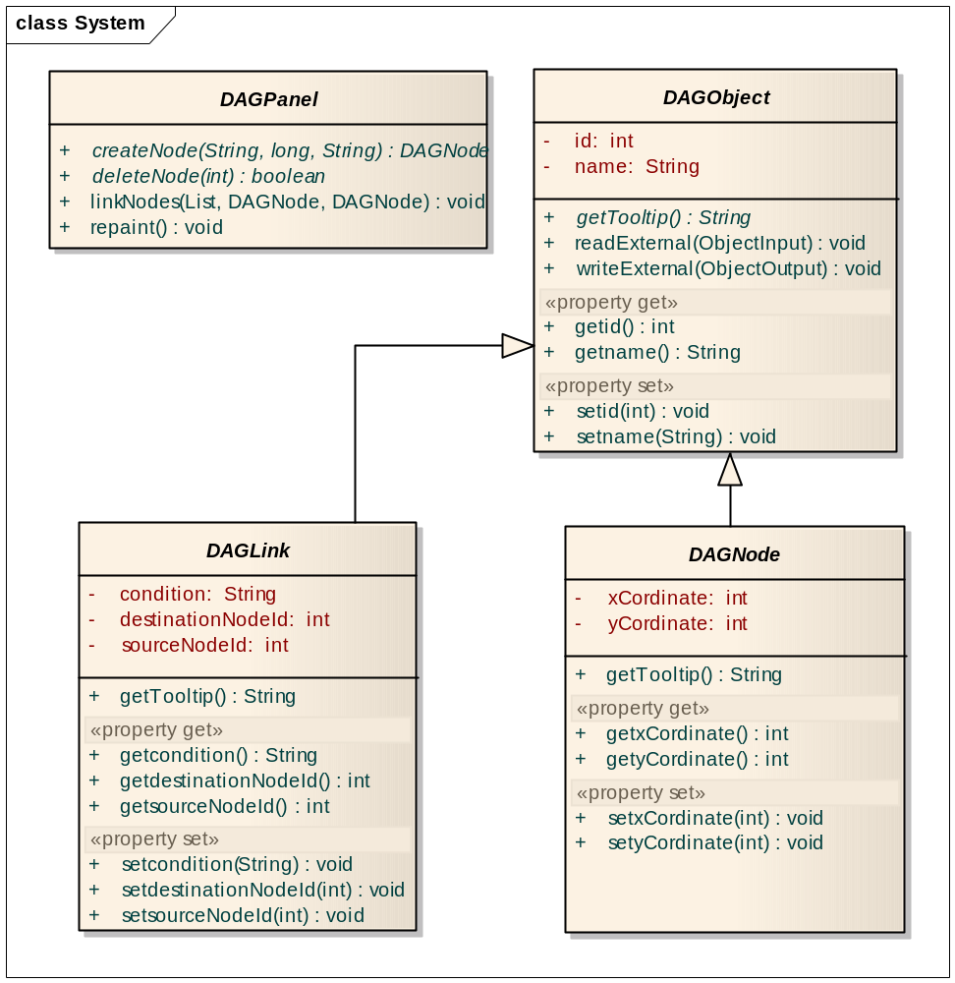
Figure 7 Class diagram of Curate Path UI

Sequence Diagram
After searching the classes from metadata search, administrator can define curate paths among these classes. On clicking the links of searched classes will add them into the DAG, select two classes at a time and click on the manual connect button on the DAG.
At this action DAG.mxml calls the getPaths() of CategoryDagPanel which calls the getCuratePaths(sourceEntity,targetEntity) of CommonPathFinder .It returns the curate paths between sourceEntity class and targetEntity class.
If there are multiple paths, ambiguity resolver pops up with all paths between source class and target class. This activity is performed for each set of classes user wants to connect. Clicking of save button will save the selected path by calling saveCuratePath(curatePath) of PathBizLogic. This method will save the curated path for the selected classes.

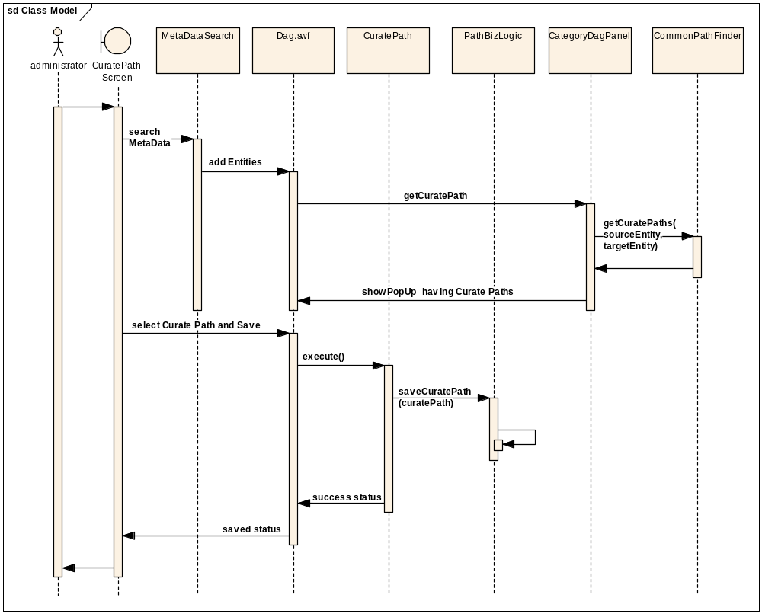
Figure 8 Sequence diagram of path curation

Category Creation

Overview
In Create Category module, different entities or classes can be combined together to generate a category. The attributes that are selected form the different entities will now collectively become attributes of category. This is analogous to join of SQL.

Sequence Diagrams
After adding entities into DAG, existing paths between two selected entities can be shown by either by clicking Manual Connect button or Auto Connect button.
On clicking Manual Connect, DAG.mxml calls getPaths(soruceEntity,targetEntity) of CategoryDagPanel which subsequently calls the getAllPath(soruceEntity,targetEntity) of CommonPathFinder. This activity returns the general/curate paths between the source and target entity. If multiple general/curate paths exist between the source and target entity, then Ambiguity Resolver pops up showing all the genera/curated paths.
On clicking AutoConnect button, DAG,mxml class calls getAutoPaths(entitySet) of CategoryDagPanel which calls the autoConnect(entitySet) of CommonPathFinder. If multiple paths exist among selected entities, then Ambiguity Resolver pops up showing all the paths. When user clicks next button, application shows all the attributes for this category in editable form on CretaeCategoryAttributeOrder.jsp. Administrator can edit the attributes names here. On clicking Save button, persistCategory(inputCategory) of PersistCategory will be called which saves the category.
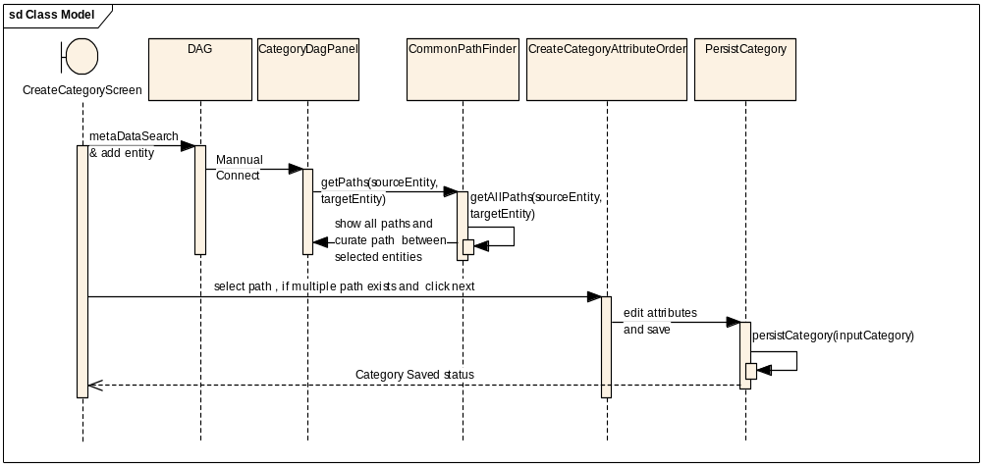
Figure 9 Category creation with Manual Connect
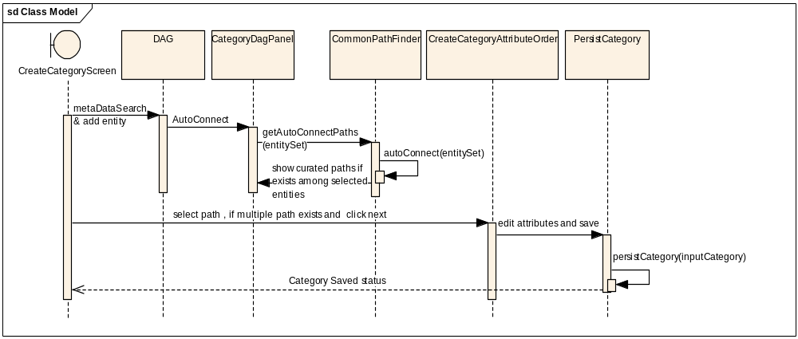
Figure 10 Category creation with Auto Connect

Inter-Model Join

Overview
In Inter-Model Join module, the concept of path curation is extended for defining paths across different models. The matching attribute is used in joining and the classes are ends of that inter-model bridge.

Class Structure
Classes involved in this module are as follows:
- InterModelConnection
This domain object represents connection / link between two entities, both from different models
- InterModelConnectionsUtil
It contains the business logic that is needed for create and persist the InterModel connection.
- InterModelMatching
This is the action class that gets two selected entities form UI and determines the possibility of their connection by calling, InterModelConnectionsUtil’s .determineConnections(entity1, entity2) method. If the two entities can be connected then it redirects the result and displays the set of attributes, through which the connection can be established.
- PersistInterModel
This is the action class that gets the attribute pair from the UI and saves the InterModel connection by calling, InterModelConnectionsUtil’s saveInterModelConnection(attributePair) method.

Database schema
Save-Update-delete operations will be performed using DAO pattern. The DDL of the tables will be
drop table if exists ASSOCIATION;
drop table if exists INTER_MODEL_ASSOCIATION;

/* Possible values for ASSOCIATION_TYPE are 1 and 2
ASSOCIATION_TYPE = 1 represents INTER_MODEL_ASSOCIATION.
ASSOCIATION_TYPE = 2 represents INTRA_MODEL_ASSOCIATION.
*/
create table ASSOCIATION(
ASSOCIATION_ID bigint not null,
ASSOCIATION_TYPE INT(8) not null ,
primary key (ASSOCIATION_ID)
);
create table INTER_MODEL_ASSOCIATION(
ASSOCIATION_ID bigint not null references ASSOCIATION(ASSOCIATION_ID),
LEFT_ENTITY_ID bigint not null,
LEFT_ATTRIBUTE_ID bigint not null,
RIGHT_ENTITY_ID bigint not null,
RIGHT_ATTRIBUTE_ID bigint not null,
primary key (ASSOCIATION_ID)
);

Sequence Diagram
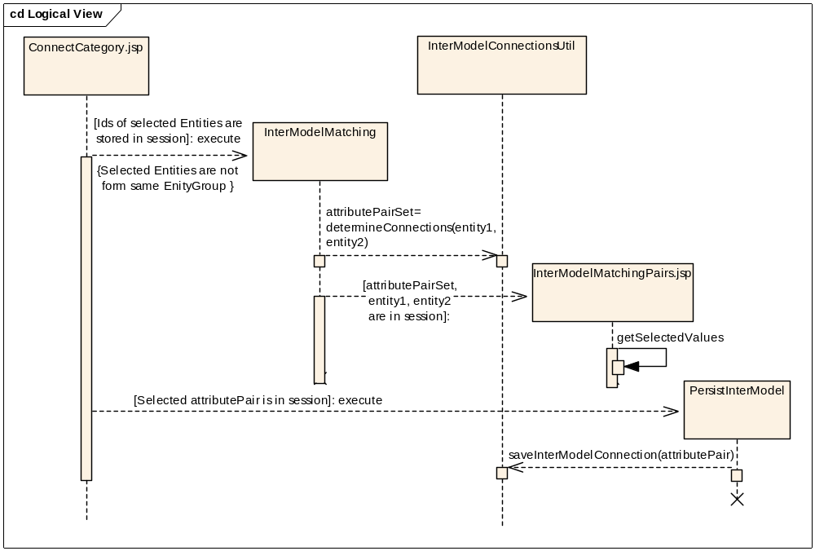
Figure 11 Sequence diagram of InterModel Join
On ConnectCategory.jsp, user selects the two node added in the DAG. Clicking “Join Classes” button invokes InterModelMaching action. Selected entities are passed to it via session.
InterModelMaching action class in turn invokes the determineConnections() of InterModelConnectionsUtil. This method determines the matching factor between the two selected classes as per the following procedure.
For curating path across two models, the administrator adds two classes, which will be the ends of inter-model bridge, in the DAG. To connect these two ends of the bridge, following process is compiled. In the process, each successive step is reached only if no results are found in the previous step.
Step 1: In models from caDSR, public ID is defined only for attributes. An attribute’s public ID is same as the Data Element public ID from the CDE browser. The application shows exact common data element (CDE) matches. E.g., application show attributes which belongs to bridge classes and which have the same public ID.
Step 2: Showing exact data element concept (DEC) match. Ideal way of doing this is matching their public ID. As these public IDs are absent in XML, this is simulated by matching the concept codes of attribute and class (not value domain) in order. If they match, that attribute is eligible for joining.
Step 3: Showing attributes having same concept codes in the same order (i.e. property and property qualifier concept codes are in the same order).
Step 4: Showing all attributes of bridge classes and ask the Administrator to select attributes to be used to join. This is manual join.
The returns set of matching attribute pairs that are displayed on InterModelMatchingPairs.jsp.
On this page user selects the pair to be used as join between the two classes. The pair is reflected in the DAG as a link between the two selected classes.
Clicking Save Join button on ConnectCategory.jsp invokes PersistInterModel action that takes selected attributePair via session.
PersistInterModel action class invokes saveInterModelConnection() of InterModelConnectionsUtil . This creates the join between the inter-model classes.

Model Groups

Requirement

User should be able to perform following operations:
- Group different models available to the user
- Define Model Group with Single model (e.g. caTissue_1_2_v1.2)
- Define Model Group with same model but different version (e.g. caArray_v2.0, caArray_v2.1 etc)
- Define Model Group with different models combined together (e.g. CaArray & caTissue)
- Modify and delete existing Model Group

Classes Involved

Server Classes:
- ModelGroupOperations.java
This class is the operations class in which all operations corresponding to model group is performed. It contains methods like
- getAllSecuredModelGroup
- getAllNonSecuredModelGroup
- getAllModelGroup
- saveModelGroup
- deleteModelGroup
- modifyModelGroup

Common Classes:
- ModelGroup.java
This class is the HO class that does the hibernate mapping. It implements the ModelGroupInterface class so that outside world can use this interface to perform different operations. Callers are expected to use the interface and not this concrete implementation

It contains five variables. All these variables have their getter and setter in this class.
modelID, entityGroupNames, modelGroupName, modelGroupDescription, secured
modelID is an auto-generated field.

entityGroupNames.
This is of type String as it contains Names of all entityGroup belonging to this group concatenated with “###” to avoid any kind of misinterpretation. The setter for entityGroupNames actually stores String but at interface level, it stores List<EntityGroupInterface>. To do this there are two different public methods which handles all these conversions and to maintain isolation with its interface.

- ModelGroupInterface.java
This is the interface class, which has used to hide the real implementation of the model Group. This class has getter and setter for all 4-member variables (ID, Name, Description and EntityGroupNames).

Database Schema
The Model_ID is the auto-generated key. Model Group Name is of type string, which should be unique and it is take care of in the code. The secured field is of Boolean type, which indicates whether the Model Group requires authentication or is accessible by Anonymous user also. The description is the description added while saving Model Group. Entity Group Names is a string, which tells which all entity groups are part of this Model Group. It is stored as ABC_v1###XYZ_v2###. “###” is used to separate two entity group name.

Model_ID  (pk) | Model Group Name  (unique) | Secured | Description | Entity_Group_Names

Sequence Diagram for Saving Model Group
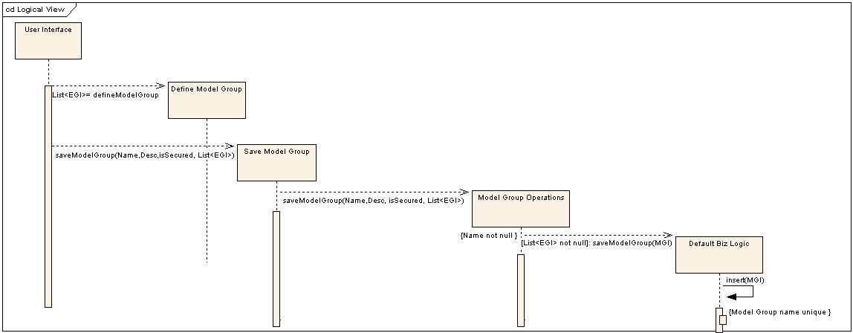
Figure 12 Save model group

